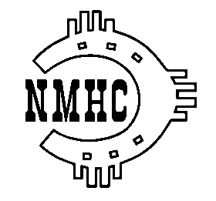
New Mexico Horse Council
AGENDA
Monthly Board Meeting – April 3, 2023, 7:00 P.M.

- Call to Order: Steve Komadina

- Welcome & introduce those on the call

- Approval of Agenda: Steve Komadina

- Approval of the March Board minutes.

- Treasurer’s Report: Patty Carroll

- Executive director Report: Danette McGuire

Unfinished Business

- Legislative Update: Chris Morgan

- Gas Company Educational Grant Status: Steve Komadina

- American Horse Council Membership: Steve Komadina

- NMHC Membership: Steve Komadina

- Membership Value, Liability Signs

- Scholarship Submissions: Danette

- Organization Memberships

- Visits to local events Value

- Questionnaire to NM Equine Organizations

